SUBJECT: Science
GRADE: 5
DATE: June 2019
DURATION: 60 minutes
UNIT: Forces and Work
TOPIC: Investigating the effects of friction
ATTAINMENT TARGET:
- Recognise the importance of energy to life processes, everyday life, and the relationship between energy and matter.
- Gain an understanding of and apply aspects of the scientific method.
- Begin to appreciate the influence and limitations of science.
- Demonstrate a positive attitude towards the use of scientific language

BENCHMARKS:
- Understand the effects of forces and the concept of work.
- Make predictions of what will happen based on scientific knowledge and understanding. Suggest and communicate how to test these predictions. Interpret data and decide whether results support predictions, and are sufficient to draw conclusions.
- Display curiosity, objectivity and perseverance in their approach to activities.

LEARNING OBJECTIVES:
During the session, students will be able to:
- Operationally define friction
- Assess the effect of friction on daily life
- Investigate the effects of friction and how these may be reduced
- Make and repeat measurements to ensure accuracy of results

Consider patterns in results in order to draw conclusions
- Show objectivity by using data to validate observations and explanations about forces
- Show perseverance in completing investigations
KEY SKILLS: Measure, record, report, draw conclusions, interpret, infer, communicate, collaborate, define operationally
KEY VOCABULARY: force, friction, rough, smooth, lubrication, resistance

MATERIALS/RESOURCES: Measuring tape or ruler, stones, sticks, marbles, balls, toy cars, paper, different surfaces (plastic, wood, rubber, sand paper etc.), ramp, computer, internet
CONTENT OUTLINE:
- Forces can either affect the size, shape or motion of an object.
- Friction is the force that opposes the motion of one object against another. Friction reduces motion by slowing down the object or causing it to stop.
- Friction can be useful in daily life, seen in everyday tasks such as walking, driving and writing. Friction can also cause machines to be less efficient as more energy is needed to operate while energy can also be lost as heat.
- The effects of friction can be reduced by using lubricants (oils) and grease on machine parts (e.g. brake fluids in cars).
- Rules and characteristics associated with perseverance (identifying aspects of task that poses difficulty or challenge, goal setting, continuous effort, acknowledging strides, remaining optimistic, adopt a never give up attitude etc.)
- Indicators of appreciation based on utterances during reflection and/or while interacting with others or with materials (praise/commendation, positive tone of expression etc.)
PRIOR LEARNING: Check that students:
- Know that a force is a push or pull
- Know some effects of forces
- Know value of accurate measurement
- Know the importance of replication

LEARNING OUTCOME: Students who demonstrate understanding can:
- Show some effects of friction
- Employ methods to reduce friction
- Show appreciation for how forces are used in different situations

ASSESSMENT CRITERIA:
- Acceptable explanations given for observations
- Acceptable inferences made
- Correct force linked with observed change
- Correct measurement of distances made
- Correct explanations given for categorizing everyday activity as useful or not useful friction
- Appropriate behaviours associated with positive attitude /s demonstrated/reflected on
PROCEDURES/ACTIVITIES
Engage & Evaluate- How can I get students interested in this? (10 min)
- Teacher will first determine students’ knowledge on forces and the effects of forces after which students will carry out Option 1 or 2 below.
- Option 1: Students will watch a video on how to make fire with sticks,
https://www.youtube.com/watch?v=BKnMB-T5VFI or https://www.youtube.com/watch?v=l8C8qPoMZdo
Option 2 Students will carry out the following actions:
- rubbing of hands together (b) rubbing of stones together (c) rubbing of sticks together.
Students will discuss what happened when they carried out the actions OR how the fire was generated in the video. Students will be led to see that a force was involved which caused heat to be formed. Teacher will introduce the term friction in the discussion.

- Students will be invited to remind each other of expectations/important rules of conduct in the science class and their significance. Teacher encourages class to support each other and observe safety rules.
Explore - What tasks/questions can I offer to help students puzzle through this? (15 min)
- Students will discuss how to plan and design an investigation to determine the effects of friction on different surfaces. Using marbles, balls or toy cars, the effects of movements on surfaces such as paper, carpet, wood or sandpaper will be discussed. Students will discuss what needs to be done to ensure a fair test with guidance from the teacher.

- A simulation using a ramp (as shown in the diagram) will be used. Students will determine the distance the object moved off the ramp. The results will be collected, interpreted and conclusions made about the effects of friction and the surfaces that had the most or least friction. Teacher will assess the plans made by students using a Designing Investigation Checklist. Students will reflect on how they ensured that the investigation followed fair testing requirements and how they persevered.

object
Explain - How can I help students make sense of their observations? (10 min)
- Students will present findings of the surface with the most or least friction using evidence from results collected and a preferred mode of communication (notes, graphic/illustrations model). Students will operationally define friction and outline the effects of friction. Teacher will check that students’ responses are scientifically correct and clarify misconceptions as necessary.
Elaborate & Explain - How can my students apply their new knowledge to other situations? (10 min)
- Students will identify everyday activities that make use of friction. Students will discuss whether friction is useful or not in these instances and complete Worksheet to identify whether pictures of activities demonstrate useful or not useful friction and give explanations for their choices.
- Students will suggest strategies that are used to reduce friction, for instance in engine brakes and moving objects across a floor.
- Advanced Students: Explain how wheels aid in overcoming or reducing frictional force
- Students with learning challenges: Name objects that use wheels to move.
Evaluate - How can I help my students self-evaluate and reflect on the teaching and learning, and how can I evaluate the students learning of concepts and skills bearing in mind the required assessment criteria . Assessment (10 min)
- Worksheet identifying friction that is useful or not useful will be assessed.
- Students’ investigation plan will be assessed using the Designing Investigation Checklist by the teacher. Students will complete a partially-filled Concept map on Friction.
- Students will complete a self-rated-reflective tool that addresses their experiences, learning, roles/responsibilities and behaviours. Corrective actions will be taken where applicable, following discussion on their assessment of self.
EXTENDED LEARNING: Students will research on the use of ball bearings in treating with friction OR research shapes (and names) of objects that reduce air or water resistance.

LINKS TO OTHER SUBJECTS: Mathematics, Resource & Technology

POST-LESSON REFLECTION:
______________________________________________________________________________

______________________________________________________________________________

______________________________________________________________________________

Activity 1: Determining whether friction is helpful or not helpful

Aim: To identify when friction is useful and when it is a problem
Skills: Analyzing, constructing explanations

Instructions: Complete the table below.

Activity | Is friction helpful or Is it a problem? | Explanation
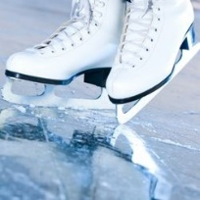
Ice skating

Train slowing
on a track
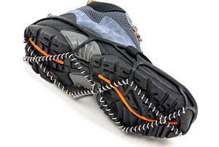
Walking on
slippery surface
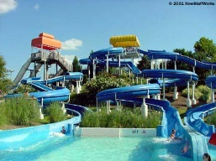
Using a water
Slide
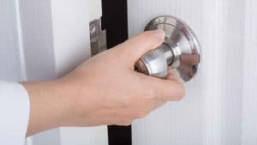
Turning a door knob
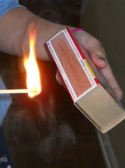
Striking a match

Concept map: Investigating Friction

Affects movement on
different surfaces
Stops movement
Slows down objects

has many effects

Friction

can be

Not Helpful
Helpful

Lubricants
Slows movement
Prevents slip and slide

Allows grip
Reduce by

Overheat
Wear and tear

Rollers and wheels

